EXPT NO: 6 | Implementation of Backtracking in N-Queens Problem
DATE: 16.09.2025

PRE-LAB QUESTIONS (Write the answers in your AI and Automation Notebook)
- What is the backtracking technique in Artificial Intelligence?
Backtracking is a systematic search technique in AI that incrementally builds solutions, abandoning partial paths when constraints are violated to explore alternative possibilities.

- How does backtracking help solve constraint satisfaction problems like N-Queens?
Backtracking helps N-Queens by placing queens one by one, backtracking whenever a placement causes conflicts, ensuring all constraints are satisfied before proceeding.

- What are the constraints in the N-Queens problem?
Constraints in N-Queens are that no two queens can share the same row, column, or diagonal on the chessboard simultaneously.

- Why is the N-Queens problem considered as a combinatorial search problem?
N-Queens is combinatorial because it involves exploring numerous possible queen arrangements, systematically searching all configurations to find valid solutions satisfying constraints.

- How does increasing the value of N affect the complexity of the problem?
Increasing N exponentially raises complexity, as the number of possible board configurations and constraint checks grows rapidly, demanding more computation time and memory.

IN-LAB EXERCISE
OBJECTIVE:
To implement the backtracking algorithm to solve the N-Queens problem, allowing the user to input the value of N and generating all valid board configurations where no two queens threaten each other.

PROCEDURE:
Problem Scenario
- Problem Type: Constraint Satisfaction Problem (CSP)
- Board: N×N grid (user-defined)
- Symbols: Queen - ' Q ', Empty Cell: ' - '
- Goal: Place N queens such that no two queens share the same row, column, or diagonal.

Implementation Steps:
Part A – 4 Queens Problem Implementation
Part B – N Queens Problem Implementation (Get ‘N’ from user)
- Accept Input from User: (Only for Part B)
- Prompt the user to enter the value of N (e.g., 4, 8, 10).
- Represent the Board:
- Use a 1D list to represent queen positions where index = row and value = column.
3. Define Constraints:
- No two queens in the same column/row.
- No two queens on the same diagonal.
4. Implement Backtracking Algorithm:
- Start from row 0.
- Try placing a queen in each column.
- Check for safety using constraints.
- If safe, place queen and move to next row.
- If all rows are filled, print solution.
- If no valid column, backtrack to previous row.
5. Display Solutions:
- Print each valid board configuration.
- Display total number of solutions found.

SCREENSHOT OF CODE – Part A | 4 Queens Problem
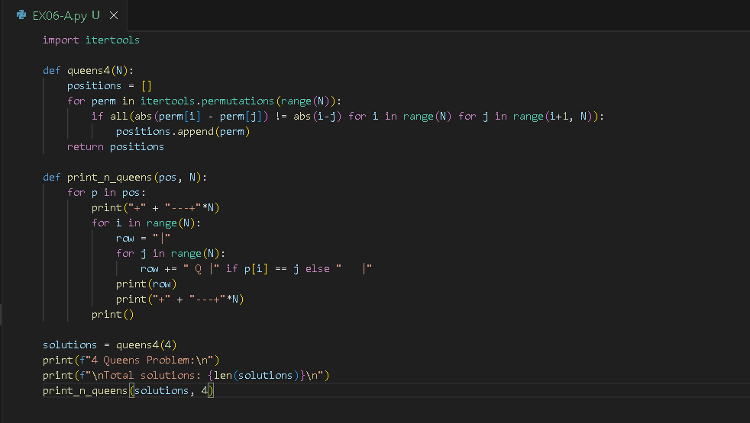
SCREENSHOT OF OUTPUT - Part A | 4 Queens Problem
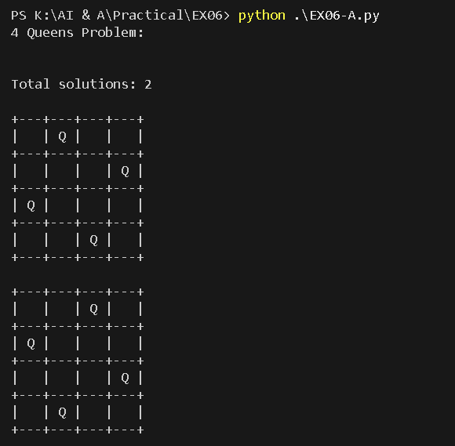

SCREENSHOT OF CODE – Part B | N Queens Problem
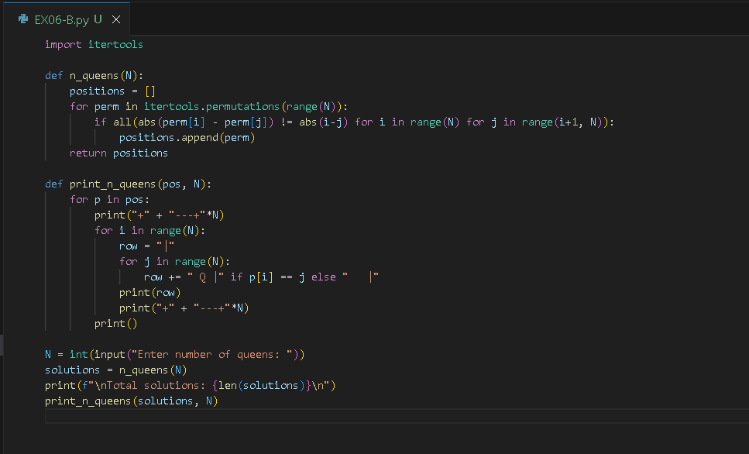

SCREENSHOT OF OUTPUT - Part B | N Queens Problem

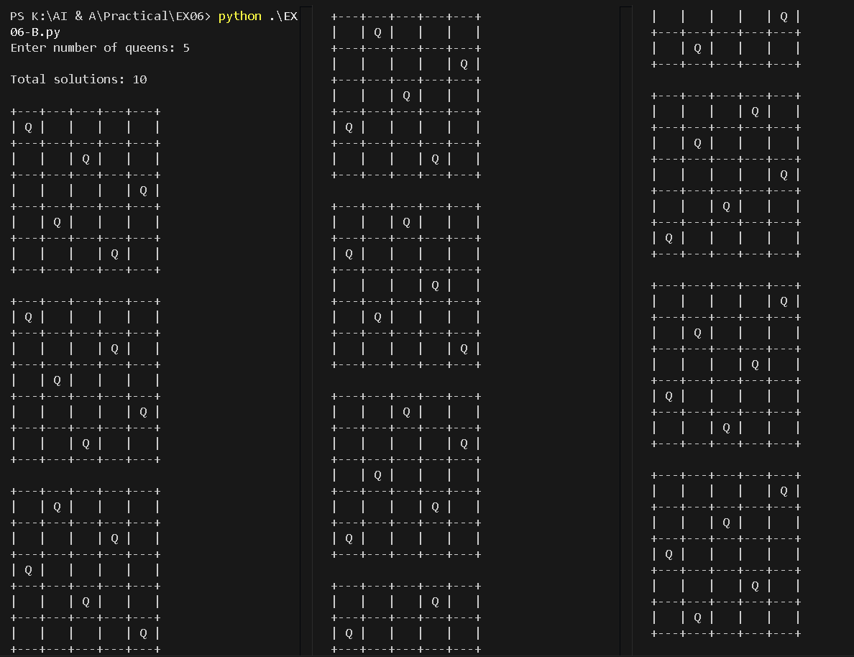

POST-LAB QUESTIONS (Write the answers in your AI and Automation Notebook)
- Why is backtracking suitable for solving the N-Queens problem?
Backtracking is suitable for N-Queens because it efficiently explores valid placements, retracting incorrect ones, reducing unnecessary searches, and ensuring constraint satisfaction systematically.

- What happens when a queen placement leads to a dead-end?
When a queen placement leads to a dead-end, the algorithm backtracks, removing the last placed queen and trying alternative positions in previous columns.

- How does the algorithm ensure that all solutions are found?
The algorithm ensures all solutions by exploring every valid configuration recursively, backtracking after each complete or failed arrangement to continue searching remaining possibilities.

- What is the time complexity of the N-Queens backtracking algorithm?
The time complexity of the N-Queens backtracking algorithm is approximately O(N!), as it explores permutations of queen placements across the board.

- How does increasing N affect the number of solutions and computation time?
As N increases, both the number of possible solutions and computation time grow rapidly, making the problem exponentially harder to solve completely.

RESULT:
The backtracking algorithm was successfully implemented to solve the 4 Queens problem and N-Queens problem for any user-defined value of N. The program generated all valid board configurations where no two queens threaten each other, demonstrating the effectiveness of recursive search and constraint satisfaction in AI problem solving.

ASSESSMENT (Write in your lab notebook)
Description | Max Marks | Marks Awarded
Pre Lab Exercise | 5
In Lab Exercise | 10
Post Lab Exercise | 5
Viva | 10
Total | 30
Faculty Signature

